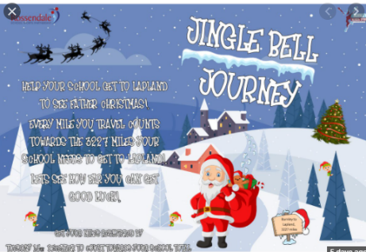
Festive dates for your diary!
Monday 22nd November to Friday 10th December – ‘Jingle Bell Journey’ where we are promoting being active in school and at home. Please encourage your child to log their daily activity.
Friday 10th December – ‘Guess the name of the penguin’ competition! More details at the back of the hall.
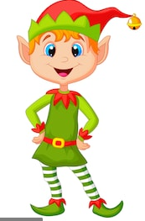
Monday 13th December – Elf Day! Come to school dressed as an elf and enjoy fun activities, hot chocolate and films! Only £1 to join in the fun!

Christmas Parties

Tuesday 14th December (PM) – Year 6
Wednesday 15th December (AM) – Year 5
Wednesday 15th December (PM) – Year 4
Thursday 16th December (AM) – Year 3
Thursday 16th December (PM) – KS1(Y1L, Y1/2H and 2F)
Children to come to school in their party clothes on their party day, they do not need any money. Please ensure they wear sensible shoes and have no jewellery on.
Friday 17th December – Christmas Jumper day! Children to wear normal school uniform with a Christmas jumper if they wish. (No money needed.)
Friday 17th December – Christmas lunch! Further details will be sent out nearer the time. This will be served in the classrooms.
Friday 17th December – End of Term – 2pm finish.

